ISVB Founding Charter

1. Name and mission
The International Society for Vocal Biomarkers ("ISVB" or "the Society") is an international, interdisciplinary society that advances the science, clinical validation and responsible use of voice and speech as biomarkers of health.
ISVB brings together clinicians, scientists, engineers, industry, regulators and patient communities to move vocal biomarkers into clinical care.

2. Objectives
- Foster collaboration across disciplines and borders.
- Promote rigorous methods for developing and validating vocal biomarkers.
- Support education and training for the next generation of researchers and clinicians.
- Advance ethical, privacy-preserving and equitable practices.
- Serve as a unified voice for the field with regulators, industry and the public.

3. Membership
Membership is open to individuals and organizations with an interest in voice and speech biomarkers, including researchers, clinicians, trainees, industry professionals and patient advocates.
- Categories and dues. The Steering Committee sets membership categories, eligibility and dues.
- Participation. Members may join Special Interest Groups (SIGs) and take part in Society activities. Members do not vote on Society governance.
- Conduct. Members follow the ISVB Member Guidelines, which include the code of conduct. The Steering Committee may suspend or end a membership for a serious breach.

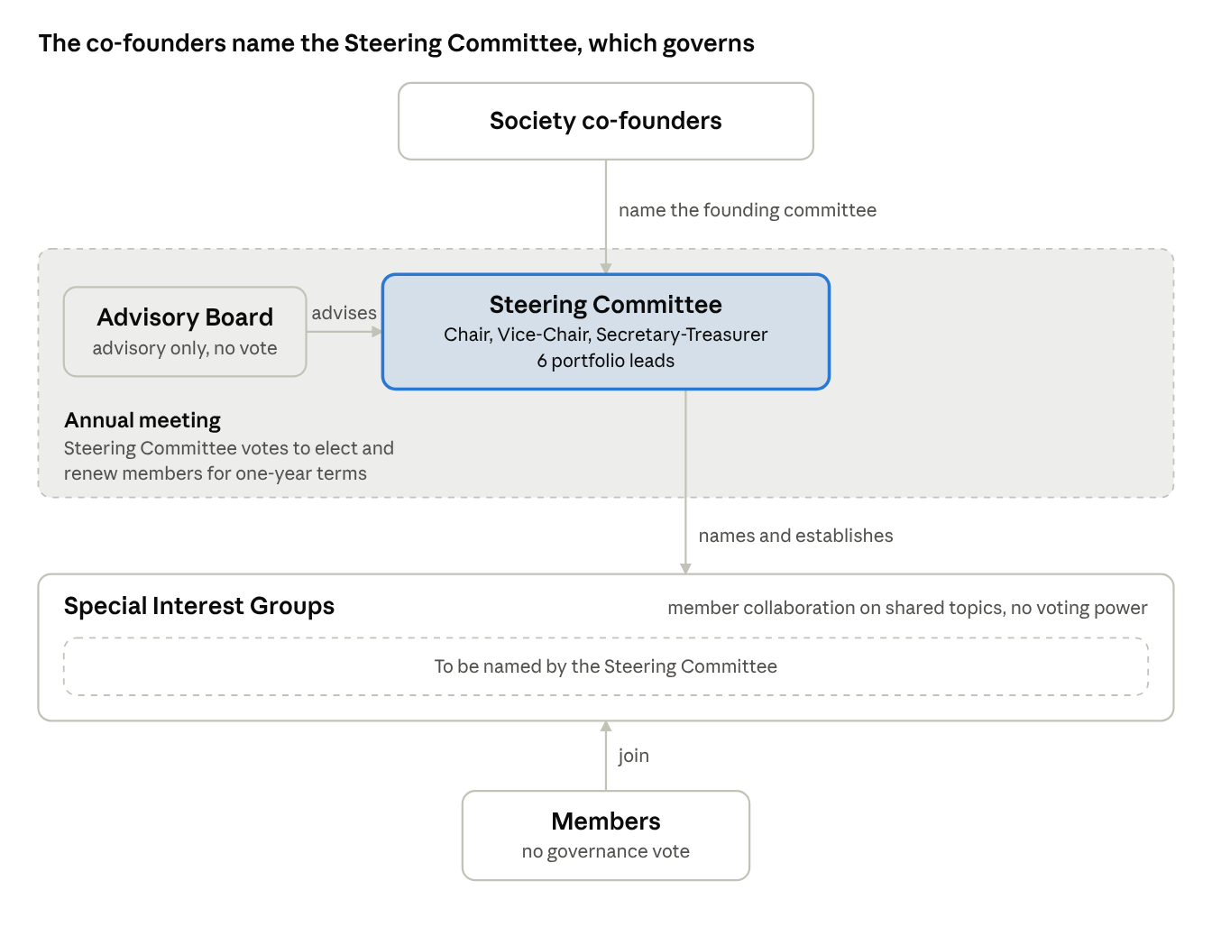
4. Governance structure
The Society's co-founders name the Steering Committee, which governs the Society. The Advisory Board advises it, and SIGs give members a place to collaborate. ISVB governance · who names, advises and joins

5. Steering Committee
The Steering Committee is the governing body of ISVB. It sets strategy, runs operations, manages finances and oversees all Society activities.

Officers
The Steering Committee elects a Chair and a Vice-Chair from its members. The Chair leads meetings and represents the Society. The Vice-Chair acts for the Chair when needed. A Steering Committee member is named Secretary-Treasurer to keep records and oversee finances.

Portfolios
Each voting member leads one portfolio.
Portfolio | Responsibilities
Education & Training | Webinars, tutorials, trainee and early-career programs
Scientific Program & Meetings | Annual meeting, symposia, abstract review
Membership & Engagement | Recruitment, international reach, member database
Communications | Website, newsletter, social media
Sponsorship & Partnerships | Industry sponsors, partnership agreements
SIG Coordination | Liaison with SIG co-chairs; brings SIG updates to Steering Committee meetings

Appointment, terms and vacancies
- The Society's co-founders name the founding Steering Committee.
- Members serve one-year terms. At each annual meeting, the Steering Committee votes to elect new members and to renew current members for another year.
- If a seat falls vacant mid-term, the Steering Committee may appoint an interim member until the next annual meeting.
- A member may be removed by a two-thirds vote of the other voting members.

Meetings and decisions
- The Steering Committee holds at least one annual meeting, joined by the Advisory Board. The Steering Committee may meet more often as needed, in person or online.
- A quorum is half of the voting members.
- Decisions pass by majority vote of members present. Votes may also be held by email or online between meetings.

6. Advisory Board
The Advisory Board gives strategic guidance and expertise and raises the Society's visibility. It includes senior leaders from academia, clinical practice, AI and engineering, industry and patient advocacy, with international representation.
- The Advisory Board is advisory only and has no voting power.
- Advisory Board members serve one-year terms. At the annual meeting, the Steering Committee appoints new members and renews current members.
- The Advisory Board meets with the Steering Committee at least once a year, at the annual meeting.

7. Special Interest Groups
Special Interest Groups (SIGs) give members a place to collaborate around shared topics of interest. SIGs have no voting or decision-making power.
- Formation. The Steering Committee names and establishes SIGs. No SIGs have been named yet. Members may suggest topics.
- Leadership. Each SIG is led by two co-chairs, appointed by the Steering Committee.
- Activities. SIGs meet regularly and may contribute to the annual meeting program or produce shared outputs, such as consensus papers, workshops or resources.
- Reporting. SIGs share updates with the Steering Committee through the SIG Coordination lead.
- Inactive SIGs. The Steering Committee may merge or close a SIG that is no longer active.

8. Conflicts of interest
Steering Committee members, Advisory Board members and SIG co-chairs disclose relevant financial and professional interests each year and whenever they change. They recuse themselves from discussions and votes where a conflict exists.
Sponsorship never buys influence over the Society's scientific content, positions or outputs. The Steering Committee adopts a written conflict-of-interest and sponsorship policy.

9. Amendments and review
- This charter may be amended by a two-thirds vote of the Steering Committee's voting members.
- The Steering Committee reviews the charter at least every two years.
- If ISVB incorporates, this charter will form the basis for formal bylaws, to be reviewed by legal counsel.

